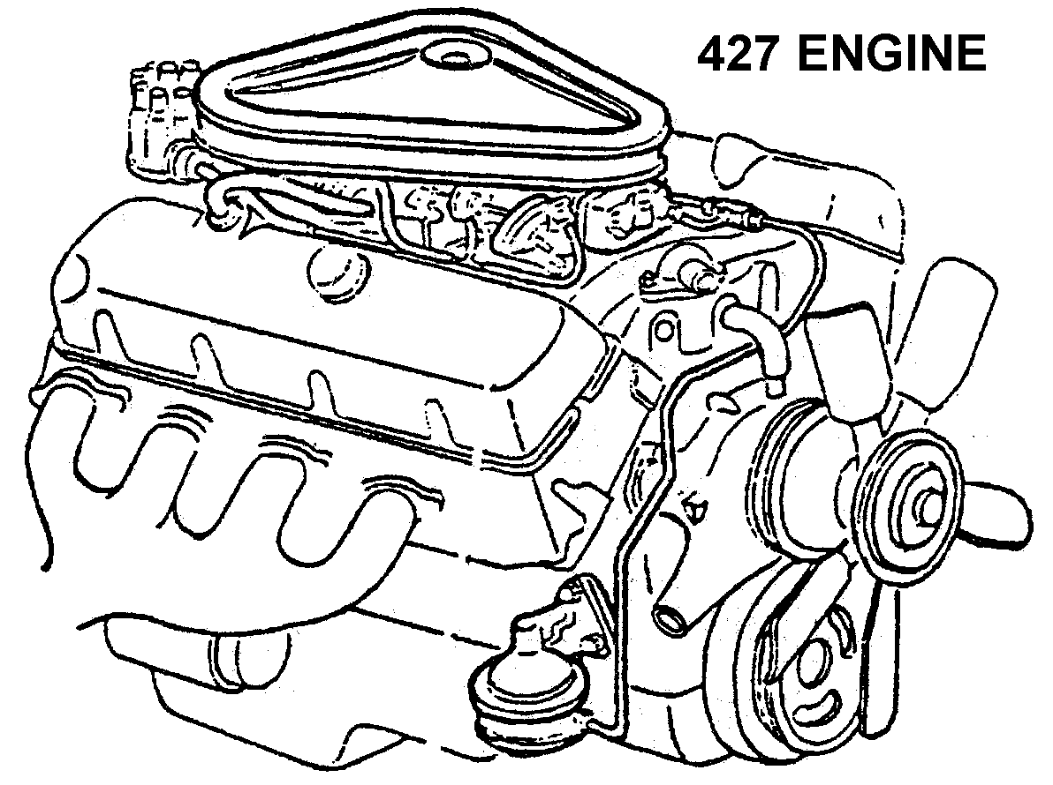
Simple Machines Notes
The 6 Simple Machines:

1.
2.
3.
4.
5.
6.

Definitions:

Energy:

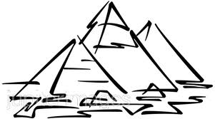
Work= __________ x ____________
Force:

The Egyptians used _______________ _________________ to build the pyramids.

Inclined Planes
- An inclined plane is a flat surface that is ______________ on one end
- Inclined planes make the work of moving things _______________.

Work input and output
- Work input is the amount of work done _____ a machine.
- Input force x ____________________
- Work output is the amount of work done _____ a machine.
- Output force x __________________
Inclined Plane - Mechanical Advantage
- The mechanical advantage of an inclined plane is equal to the ___________ of the slope divided by the ____________ of the inclined plane.
- While the inclined plane produces a mechanical advantage, it does so by increasing the ________________ through which the force must _____________.
Wedges
- Two inclined planes joined back to back.
- Wedges are used to ___________ things.

Wedge – Mechanical Advantage
- The mechanical advantage of a wedge can be found by dividing the _________ of either slope (S) by the _______________ (T) of the big end.

First Class Lever
- Fulcrum is between EF (______________) and RF (___________)
- Effort moves farther than Resistance.

Draw and Label:
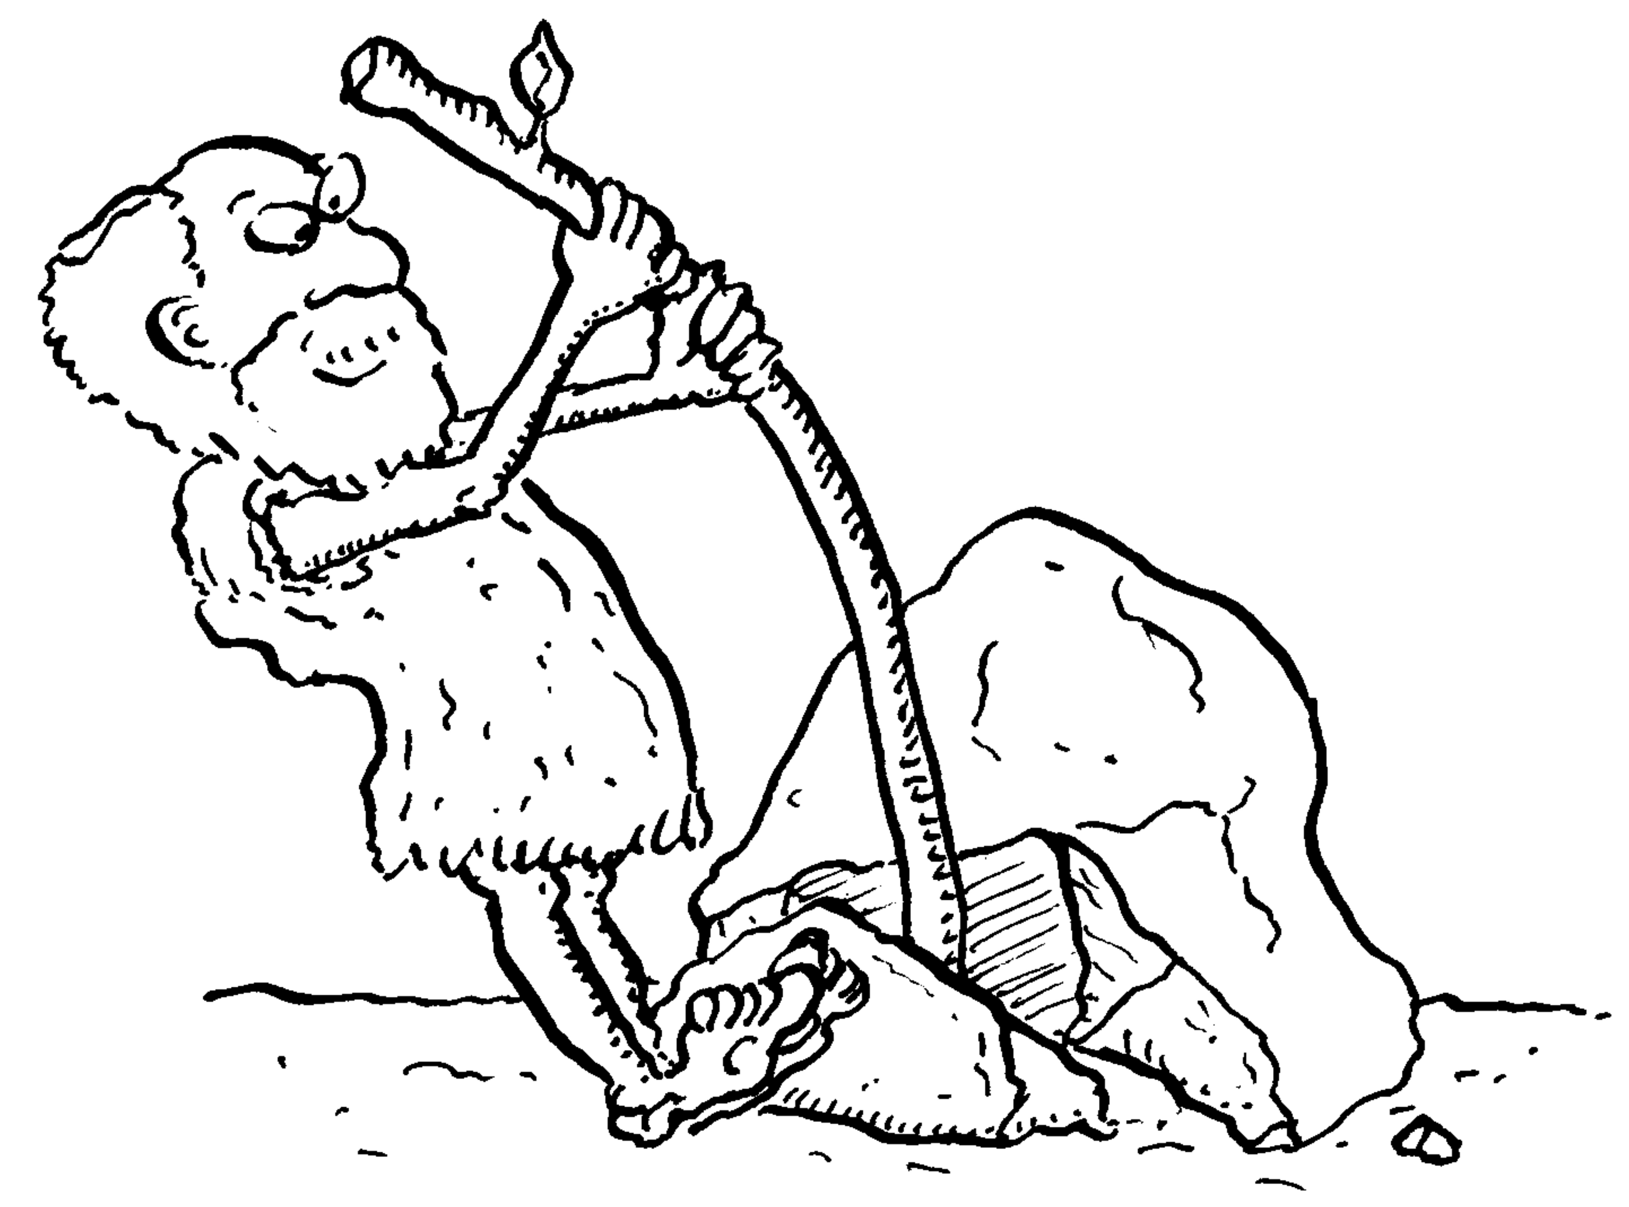

Examples:

Second Class Lever

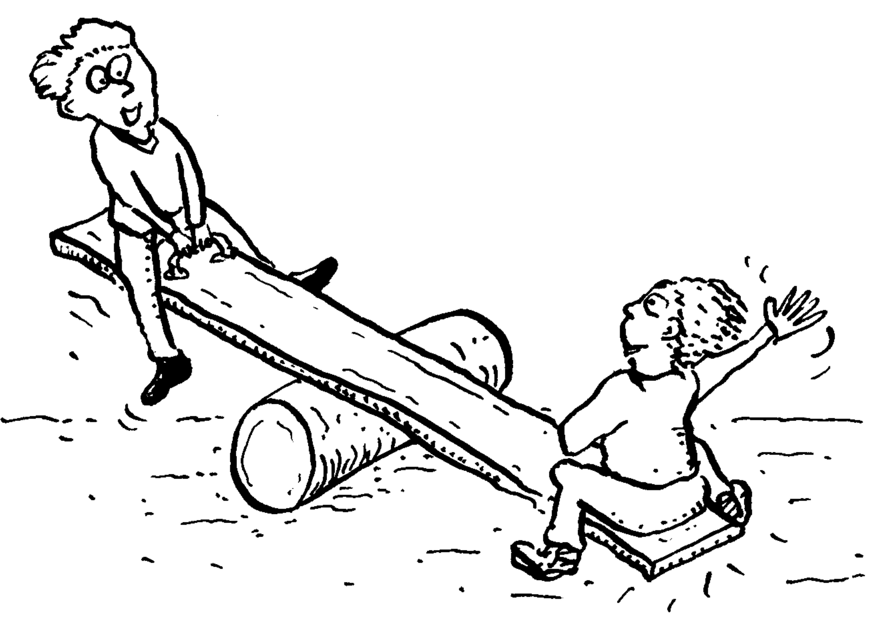
- RF (_____________) is between fulcrum and EF
- Effort moves farther than Resistance.
Draw and Label:

Examples:

Third Class Lever
- EF is between fulcrum and RF (____________)
- Does not multiply force Resistance moves farther than Effort.
Draw and Label:

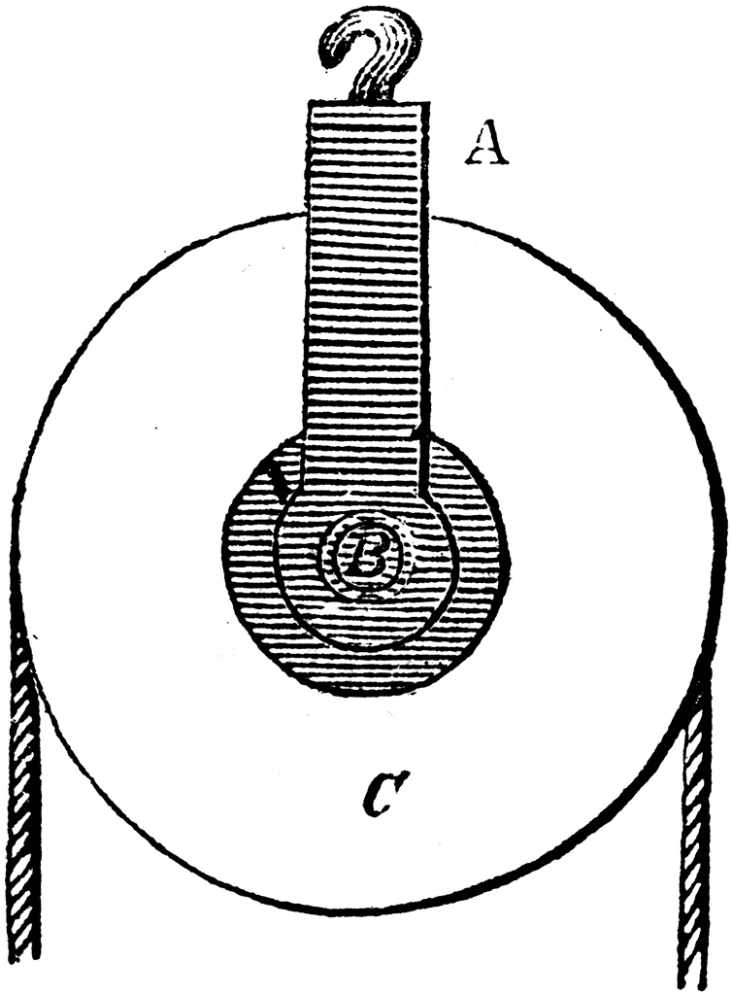
Examples:

Pulleys
- Pulley are ___________ and ___________ with a groove around the outside
- A pulley needs a rope, chain or belt around the _____________ to make it do work

Fixed pulley
A fixed pulley changes the _____________ of a force; however, it does not create a mechanical advantage.

Draw:

Movable Pulley
The mechanical advantage of a moveable pulley is equal to the _____________ of ropes that support the moveable pulley.

Draw:

Combined pulley
The effort needed to lift the load is less than __________ the weight of the load .

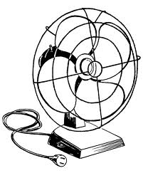
Draw:

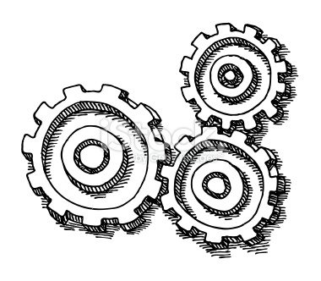
Wheel and Axel
The __________ is stuck rigidly to a large ____________. Fan blades are attached to the wheel. When the axel turns, the fan blades spin.
GEARS- Wheel and Axel
Each gear in a series _____________ the direction of rotation of the previous gear. The _ _____________ gear will always turn faster than the ____________ gear.

Rube Goldberg Machines
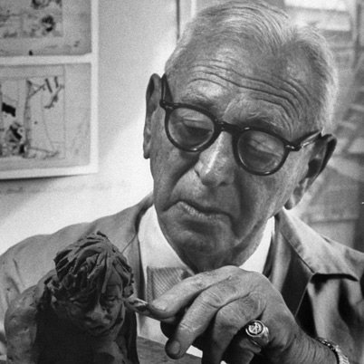
Rube Goldberg machines are usually a complicated _________________ of simple machines.

