Biological Energy - Oh Where, Oh Where Did the Energy Go?
All energy for life on Earth comes from the sun. After the energy leaves the sun it is used by plants on Earth where photosynthesis converts it to sugars. The plants store chemical energy that can be used by the plants, or converted into mechanical energy within an organism (e.g. an animal which eats the plant.) Photosynthesis is the process that explains how energy from the sun is captured by green plants and used to make food. Most of this energy is used to carry on the plant's life activities. The rest of the energy is passed on as food to the next level of the food chain.
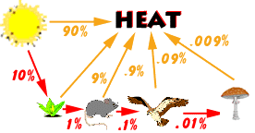The figure at the left shows energy flow in a simple food chain. Notice that at each level of the food chain, about 90% of the energy is lost in the form of heat. The total energy passed from one level to the next is only about one-tenth of the energy received from the previous organism. This means that an animal eating a plant will only get about ten percent of the energy that is stored in the plant. The remainder of the plant's energy is unusable as energy by the animal. Therefore, as you move up the food chain, there is less energy available. Animals located at the top of the food chain need a lot more food to meet their energy needs.
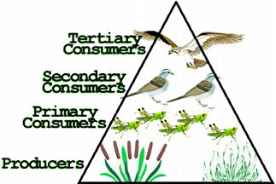
As light energy is transferred between living organisms some energy is used by the organism which obtains the food. Because of the amount of energy that is lost as you move from one level to the next typically, food chains do not usually include more than three to five organisms.
This activity allows you to explain how a food chain can be modeled by indicating the direction of energy flow. Using an arrow to indicate the direction that the energy flows (the arrow points to the organism that gets the energy.)
Below are several food chains. Use the list of organisms provided for each food chain and place these organisms in order according to the flow of energy. Remember to begin with energy coming to Earth. The path should go from the original source to the last organism to use the energy. Each of the items in the list should only be used once on a line.
- Hawk, Bunny Rabbit, Sun, Lettuce
1. ______________ _____________ _____________ ______________Snake
- Cricket, Rat, Seed, Sun, Eagle
2. ______ ______ ______ _______ ________ ______
- Cod, Algae, Sun, Krill, Leopard Seal, Killer Whale
3. _______ ________ ________ _______ ______ _____
- Sun, Herbivore, Carnivore, Producer, Top Carnivore
4. __________ __________ __________ ___________ _________
- Shrubs, Sun, Mountain Lion, Deer
5. ______________ ______________ ______________ _____________
- Grass, Cow, Human, Sun
6. ______________ ______________ ______________ ______________
- Snake, Lizard, Hawk, Sun, Grasshopper, Plant
7. _______ _______ ________ _______ _______ _______
8. How is a food web different from a food chain?

9. How much energy is lost at each level? How does it get lost?

Extension:
Take turns comparing what you ate for breakfast, lunch, or dinner with a friend. See if each of you can determine what level of the food chain your food came from.

