PHYSICAL SCIENCE NAME ______________________________________
NEWTON’S LAWS WORKSHEET

I. NEWTON’S FIRST LAW OF MOTION

- Newton’s first law of motion is also known as the LAW OF ______________________________________.

- Newton’s first law says that
- an object that IS NOT MOVING, or is at ___________________________, will stay at ___________________, AND
- an object that IS MOVING will keep moving with constant __________________________, which means at the same _____________________ and in the same ________________________, UNLESS
- an ______________________________ force acts on that object.

- What is inertia?

- What property of an object determines how much inertia it has?

- Which of the following has more inertia?
  - Bowling ball or Tennis ball
  - Hammer or Feather

II. NEWTON’S SECOND LAW OF MOTION

- Newton’s second law of motion is also known as the LAW OF ______________________________________.

- Newton’s second law says that when an __________________ force is applied to a ________________, it causes it to ____________________________.

- The greater the force that is applied, the ____________________ the acceleration.
- The lesser the force that is applied, the _____________________ the acceleration.

- If the same force is applied to an object with a large mass, it will have a _______________________ acceleration.
- If the same force is applied to an object with a small mass, it will have a _______________________ acceleration.

- The equation that is used to solve second law problems is F = ma.
  - What do each of the variables mean?
F = ______________________ m = _________________________ a = __________________________
  - What unit of measurement must be used with each variable?
F = ______________________ m = _________________________ a = __________________________

III. NEWTON’S THIRD LAW OF MOTION
- Newton’s third law of motion is also known as the LAW OF _______________________________________________.
- Newton’s third law says that every time there is an ______________________________ force, there is also a _______________________ force that is ______________________ in size and acts in the ____________________________ direction.
- Newton’s third law states that forces must ALWAYS occur in ___________________________.
- Listed below are ACTION forces. Tell the REACTION force.
  - Your bottom pushing on your desk seat c. Your finger pressing on your phone screen while texting
  - A bat hitting a baseball
IV. UNDERSTANDING…..
Label each of the following images/descriptions below as being examples of 1st, 2nd, or 3rd law. Then EXPLAIN your answer!
1st law 2nd law 3rd law
Explanation: ____________________________________________________________________________________________________________________________________________________________________________________________________________________________

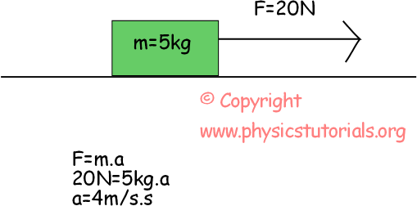

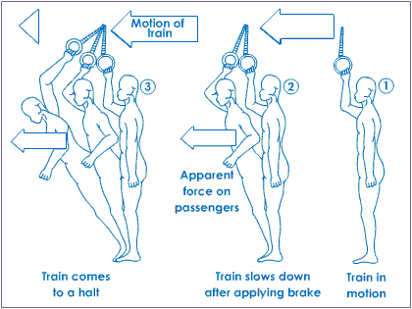
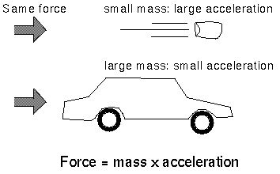
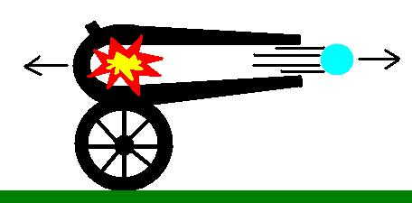
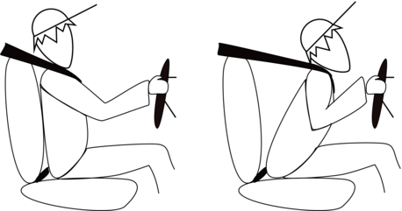
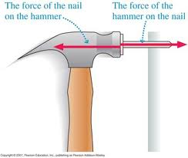
1st law 2nd law 3rd law
Explanation: ____________________________________________________________________________________________________________________________________________________________________________________________________________________________

1st law 2nd law 3rd law
Explanation: ____________________________________________________________________________________________________________________________________________________________________________________________________________________________

1st law 2nd law 3rd law
Explanation: ____________________________________________________________________________________________________________________________________________________________________________________________________________________________

1st law 2nd law 3rd law
Explanation: ____________________________________________________________________________________________________________________________________________________________________________________________________________________________

1st law 2nd law 3rd law
Explanation: ____________________________________________________________________________________________________________________________________________________________________________________________________________________________

