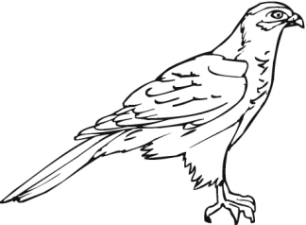
Notes for Organism Relationships

The three categories for a food chain are
1)
2)
3)

1) Producers: _____________________________________________________________________ (Plants)

2) Consumers: ___________________________________________________________________(Animals)

There are ___________ types of Consumers
1) Carnivores
2) Herbivores
3) _______________

Carnivores: only eat meat (other animals)

Herbivores: _________________________________________________________________________

Omnivores: eat both ________________ (animals) and _______________.

3) Decomposers: eat _____________things and turn them back into dirt, or ____________.

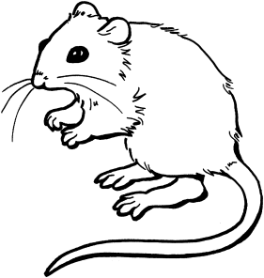
Examples:
1) Mushrooms
2) ________________
3) ________________

Describe the following animals as either a producer, consumer or decomposer. For the consumers, make sure to include if they are a carnivore, herbivore or omnivore. Please use complete sentences! (Ex: A _____ is a ______.)

1)

2)

3)

4)

5)

6)

7)

8)

9)
10)

