1. Define Mass

2. What unit do we use to measure mass?

3. Define Weight

4. What unit do we use to measure weight?

5. Does the mass or weight change on a rocket ship when it travels to a different planet? Why?

6. What two factors affect the amount of gravitational pull on object has?

Use the chart below to answer the next two questions:
Planet | Mass of a tennis ball  on that planet  thplanet | Weight of a tennis ball  on that planet
Earth | 0.05 kg | .441 N
Mars | 0.05 kg | .169 N
Jupiter | 0.05 kg | 1.12 N
Pluto | 0.05 kg | .026 N
7. Which planet has the least gravitational pull?

8. Which planet has the greatest mass? How do you know?

9. If you drop a tennis ball why will it never bounce back as high as where you drop it from?

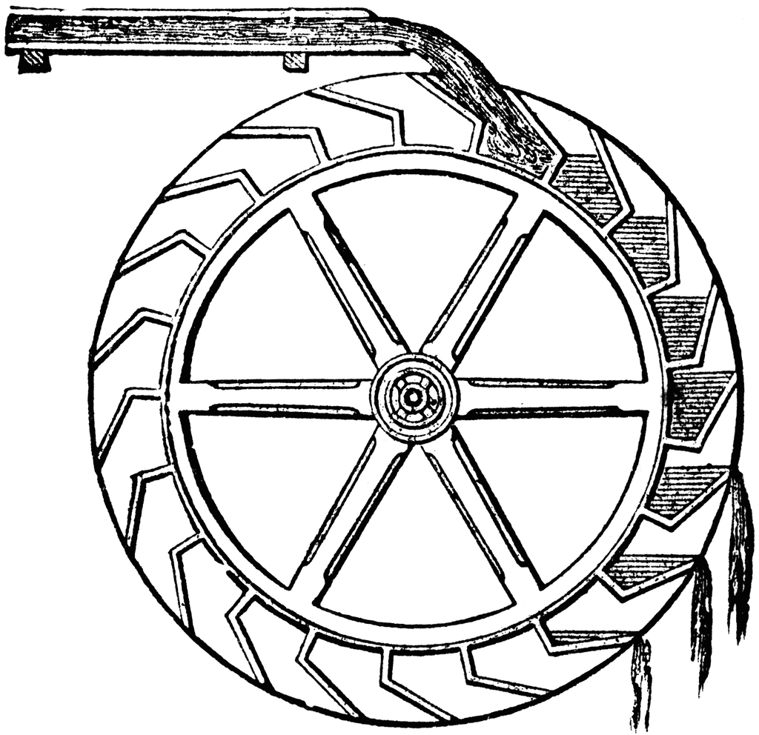
10. A water wheel is pictured below. This machine creates energy when it spins. Explain how gravity makes it possible for this machine to work.

11. Describe 3 examples where humans attempt to reduce friction on objects

12. Describe three examples where humans try to increase friction on objects

14. What would happen if there was no friction between you and the floor?

15. What type of force is gravity?
16. What force will eventually cause a skydiver stop accelerating and maintain a constant velocity?

17. Would happen to the force between the moon and earth if the distance between them was reduced? How do you know this?
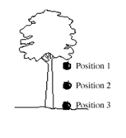
18. If there is no air resistance, what will happen If you drop a feather and a brick from the same height at the same time? Why does this happen?

19. The drawing to the left shows an apple falling to the ground. In which of the 3 positions does gravity act on the apple? Explain your answer.

